Dear families,

We are excited to announce that our preschool students will be using Seesaw. What is Seesaw?

- Seesaw is an electronic platform where students “show what they know” using photos, videos, drawings, text, PDFs, and links.
- Seesaw is a simple way for teachers and students to record and share what's happening in the classroom.
- Seesaw gives students a place to document their learning, be creative and learn how to use technology.
- Each student gets their own journal and will add things to it, like photos, videos, drawings, or notes.
- When there are new Seesaw posts, families can be notified via app notification, email or SMS.
- Parents are only notified about their own child’s work, and all data is safe and secure.
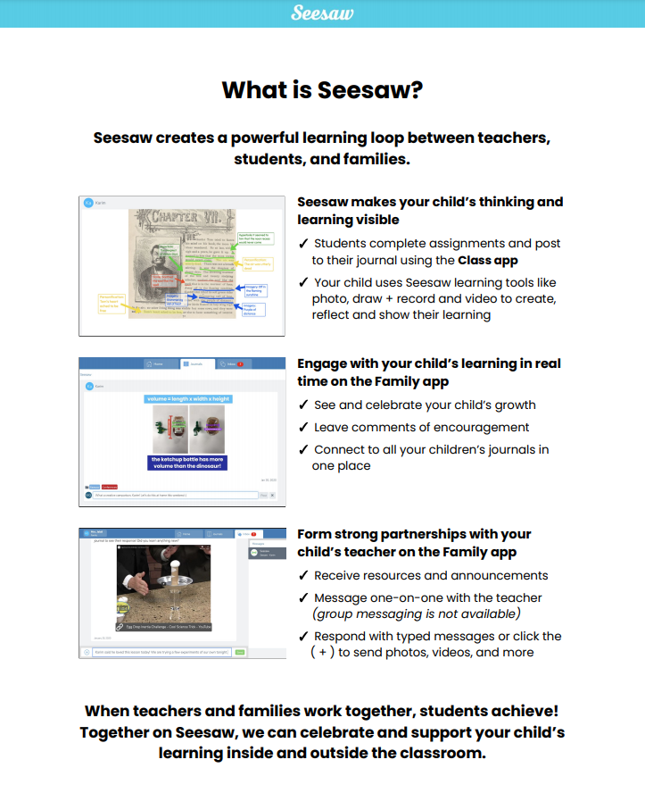

Sometimes students work in groups which means that your child may appear in other students online Seesaw post. For this to happen we need your permission. Could you please tick the relevant box below and return to the school ASAP.

Seesaw permissions

Yes, I give permission for my child’s work/picture/voice to be included in another child’s post in the same year level.

No, I do not give permission for my child’s work/ picture/voice to be included in another child’s post in the same year level.

Child’s name:___________________________ class:________________

Parent’s signature:______________________ date:________________

